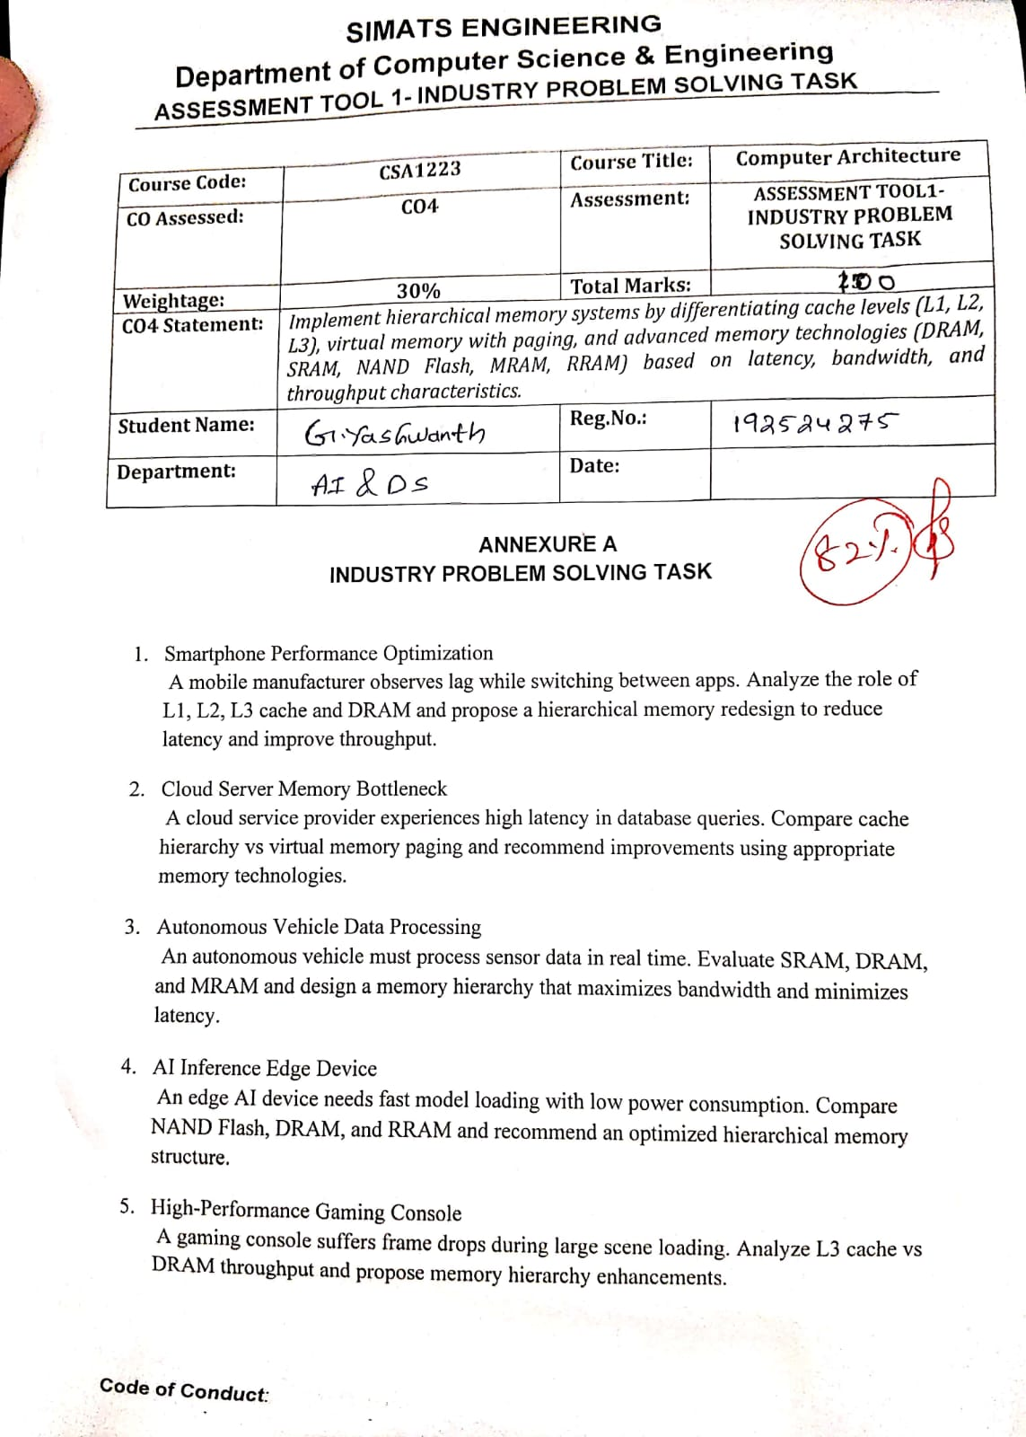

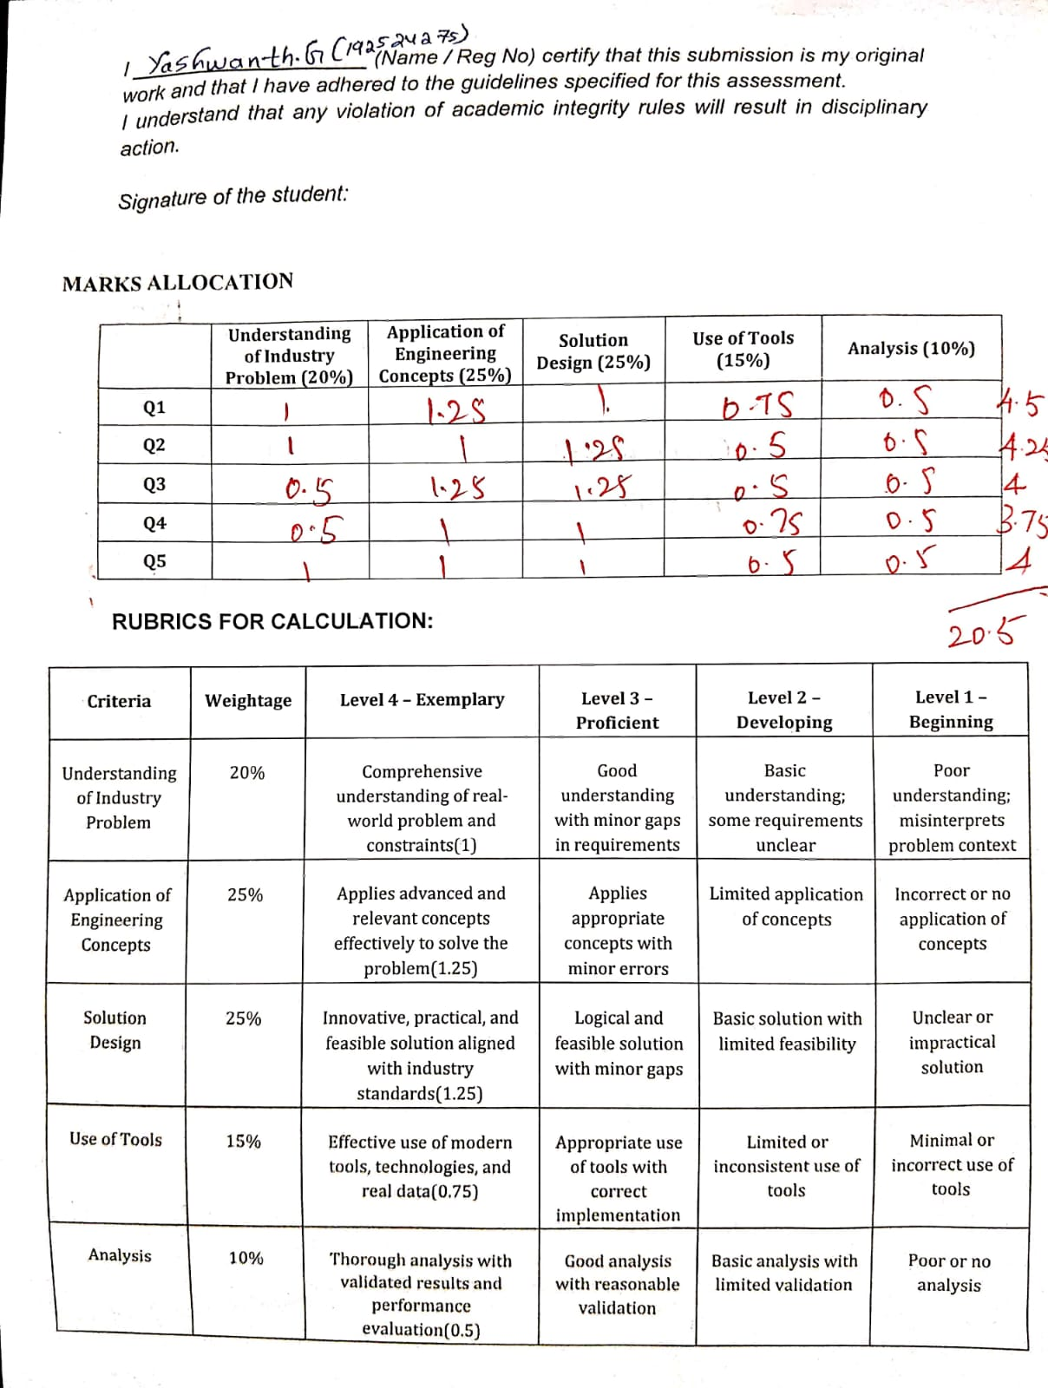

Q1. Smartphone Performance Optimization Problem Understanding
The smartphone experiences lag while switching between applications because frequently used instructions and data may not be available in the fastest cache levels. Accessing DRAM is significantly slower than accessing CPU caches. Therefore, an optimized hierarchical memory system is required to reduce memory access latency and improve application-switching performance. The problem specifically involves L1, L2, L3 cache and DRAM.

Engineering Concepts
- L1 Cache: Smallest and fastest cache, located closest to the CPU cores. It stores frequently accessed instructions and data.
- L2 Cache: Larger than L1 but slightly slower; provides additional fast storage when data is not found in L1.
- L3 Cache: Larger and generally shared among CPU cores. It reduces the number of accesses to DRAM. • DRAM: Main memory with much larger capacity but higher latency than cache.

Proposed Memory Hierarchy
CPU Core → L1 → L2 → L3 → DRAM
The smartphone should use:
- Larger and efficiently managed L1 cache for frequently executed instructions.
- Adequate L2 cache for application-specific working data.
- A shared L3 cache to reduce DRAM accesses when multiple applications are active.
- High-bandwidth LPDDR DRAM for efficient transfer of large application data.
- Effective cache replacement and prefetching techniques to predict frequently required data.

Tools/Technologies
Performance can be evaluated using CPU profiling tools, cache-miss counters and memory-bandwidth benchmarks. Cache hit rate, miss rate and average memory access time can be measured before and after the redesign.

Analysis
The redesign improves performance because most frequently accessed data can be served by L1/L2/L3 instead of slower DRAM. This reduces average memory access latency and improves throughput during application switching. Final Design:
CPU → L1 → L2 → Shared L3 → LPDDR DRAM
This hierarchical approach provides a practical balance between latency, capacity and throughput.

Q2. Cloud Server Memory Bottleneck Problem Understanding
The cloud service provider experiences high database-query latency. The problem requires comparison between cache hierarchy and virtual-memory paging, followed by selection of appropriate memory technologies.

Engineering Concepts
Feature Cache Hierarchy Virtual Memory
Main purpose Reduce CPU memory latency Extend usable address space
Typical levels L1, L2, L3 Pages in RAM + storage
Speed Very high Lower when page faults occur
Location Close to CPU RAM and secondary storage
Main issue Cache misses Page faults
Cache is used to provide very fast access to frequently used data, whereas virtual memory uses paging to manage memory beyond physical RAM capacity.

Proposed Solution
The cloud server should use:
CPU → L1 → L2 → L3 → DRAM → NVMe/SSD
- Increase effective L3 cache utilization for frequently accessed database data.
- Provide sufficient high-bandwidth DRAM to keep active database working sets in memory.
- Reduce unnecessary paging by providing adequate physical memory.
- Use SSD/NVMe storage for backing virtual memory where paging cannot be avoided.
- Optimize database indexes and query caching to reduce repeated memory accesses.

Recommended Technologies
- SRAM: For CPU caches because of its low latency.
- DRAM: For main server memory because it provides high capacity. • NAND Flash/SSD: For persistent storage and paging support.

Analysis
Cache misses can increase CPU memory-access latency, while page faults can cause much larger delays because data may need to be obtained from storage. Therefore, the primary objective should be to keep frequently accessed database data in cache and DRAM and minimize paging.
Conclusion: Increasing DRAM capacity and optimizing cache usage should be prioritized before relying heavily on virtual-memory paging.

Q3. Autonomous Vehicle Data Processing Problem Understanding
An autonomous vehicle must process sensor data in real time. Therefore, the memory system must provide low latency and high bandwidth while maintaining reliable operation. The question requires evaluation of SRAM,
DRAM and MRAM.

Engineering Concepts
Memory Main Advantage Application
SRAM Very low latency CPU/cache memory
DRAM High capacity and bandwidth Main working memory
MRAM Non-volatile and fast Persistent/embedded memory

Proposed Hierarchy
Processing Unit → SRAM Cache → DRAM → MRAM
SRAM
Use SRAM for:
- Frequently accessed sensor-processing instructions.
- Critical real-time data.
- Low-latency cache operations.
DRAM
Use high-bandwidth DRAM for:
- Camera frames.
- LiDAR/radar data.
- Intermediate AI-processing data.
- Large sensor datasets.
MRAM
Use MRAM for:
- Non-volatile storage of important configuration data.
- Fast recovery information.
- Embedded systems where persistence is useful.

Solution Design
The vehicle should prioritize sensor data according to urgency:
Critical real-time data → SRAM
Large active datasets → DRAM
Persistent configuration/state → MRAM Analysis
SRAM minimizes latency for time-critical operations, while DRAM provides the capacity and bandwidth required for large sensor datasets. MRAM adds non-volatility and can improve system recovery and reliability.
Final Design:
A hybrid SRAM + high-bandwidth DRAM + MRAM architecture provides an effective balance between latency, capacity, bandwidth and persistence.

Q4. AI Inference Edge Device Problem Understanding
The edge AI device requires fast model loading and low power consumption. The problem compares NAND Flash, DRAM and RRAM and requires an optimized hierarchical memory structure.
Engineering Concepts

Memory Key Property Proposed Use
NAND Flash Non-volatile, high capacity Model storage
DRAM Fast volatile memory Active model execution
RRAM Non-volatile, potentially low-power memory Fast/persistent model-related storage

Proposed Architecture
AI Processor → DRAM → RRAM → NAND Flash
A practical implementation can use:
NAND Flash → RRAM/DRAM → AI Accelerator Working
- NAND Flash stores complete AI models because it provides high-density persistent storage.
- Frequently used model components can be moved into DRAM for rapid inference.
- RRAM can be used for persistent or frequently accessed model parameters where the platform supports it.
- Data should be loaded only when required to reduce unnecessary memory transfers.
- Power-management techniques should place unused memory components into low-power states.

Analysis
NAND Flash provides capacity but has higher access latency than working memory. DRAM provides faster access during model execution, while RRAM can provide non-volatile storage with potentially lower access energy for suitable workloads.

Final Design
NAND Flash → RRAM/DRAM → AI Accelerator
This architecture provides:
- Fast model loading
- Lower unnecessary data movement
- Reduced power consumption
- Persistent model storage
- Efficient edge-AI inference

Q5. High-Performance Gaming Console Problem Understanding
The gaming console experiences frame drops while loading large scenes. The problem requires analysis of L3 cache versus DRAM throughput and a suitable memory hierarchy enhancement. Engineering Concepts
L3 Cache
- Lower latency than DRAM.
- Stores frequently accessed CPU data.
- Helps reduce CPU-to-DRAM accesses.
- Limited capacity.
DRAM
- Much larger capacity.
- Provides high bandwidth for large datasets.
- Suitable for game textures, scene data and other large working sets. • Has higher latency than CPU cache.
Proposed Hierarchy
CPU → L1 → L2 → L3 → High-Bandwidth DRAM → SSD

Solution Design
- Optimize L3 cache utilization for frequently accessed game-engine data.
- Use high-bandwidth DRAM to handle large textures and scene datasets.
- Use efficient memory prefetching to load data before it is required.
- Minimize unnecessary transfers between storage and DRAM.
- Use fast SSD storage for persistent game assets.
- Optimize game-engine memory allocation to reduce cache misses.

L3 vs DRAM Parameter L3 Cache DRAM Latency Lower Higher Capacity Smaller Much larger Bandwidth High for CPU access High for large data transfers Best use Frequently accessed data Large game datasets Analysis
Increasing L3 cache alone cannot solve large-scene loading because game scenes can exceed cache capacity. Highbandwidth DRAM is therefore essential for large data transfers, while L3 cache should handle frequently reused CPU-side data.

Final Recommendation
CPU → L1 → L2 → Larger/optimized L3 → High-bandwidth DRAM → SSD
This combination reduces cache misses, improves data availability and helps maintain consistent frame processing during large scene loading.

